

**Department of Electronics and Communication Engineering**

**III IA EVALUATION REPORT**

***for***

**BLENDED LEARNING PROJECT BASED LEARNING**

***A report submitted by***

|  |  |
| --- | --- |
| ***Name of the Student*** | **BRIJIN** |
| ***Register Number*** | **URK22EC1021** |
| ***Subject Name*** | **PYTHON PROGRAMMING** |
| ***Subject Code*** | **20EC1001** |
| ***Date of Report submission*** | **28/04/2023** |

**Project Rubrics for Evaluation**

**First Review:** to be awarded for **10 Marks** – PPT should have four slides (Title page, Introduction, Description of Project).

**Second Review:** to be awarded for **10 Marks** – PPT should have three slides (Description of Concept and Partial Results)

**Third Review:** to be awarded for **10 Marks** – PPT should have two slides (Tool based simulation/Video Presentation)

**Fourth Review:** to be awarded for **10 Marks** –PPT should have two slides (Output Results & Discussion)

**Total marks: _____/ 40 Marks**

**Signature of Faculty with date:**



**TABLE OF CONTENTS**

|  |  |  |
| --- | --- | --- |
| **CHAPTER** | **TITLE** | **PAGE NO.** |
|  | **INTRODUCTION** |  |
|  | **DESCRIPTION OF THE PROJECT** |  |
|  | **DESCRIPTION OF THE PYTHON LIBRARIES AND FUNCTIONS INVOLVED** |  |
|  | **DETAILS OF THE HARDWARE/SOFTWARE USED IN THE PROJECT** |  |
|  | **RESULTS AND SIMULATIONS SCREENSHOTS** |  |
|  | **CONCLUSION** |  |

**CHAPTER 1**

**INTRODUCTION**

Wikipedia is a vast online encyclopedia with a plethora of information on various topics. To explore Wikipedia using Python, we can use the Wikipedia API. The Wikipedia API allows us to retrieve information about a particular topic or article from Wikipedia programmatically.

To get started with the Wikipedia API, we first need to install the "wikipedia" library in Python. This can be done using the pip package manager. Once the library is installed, we can use it to search for articles, retrieve information about articles, and extract specific pieces of information from articles.

**DESCRIPTION OF THE PROJECT**

A Wikipedia explorer in Python is an application or script that allows users to search for and retrieve information from Wikipedia using the Wikipedia API. The application can be built using the "wikipedia" library in Python, which provides an easy-to-use interface for accessing Wikipedia.

The Wikipedia explorer can be designed to have a graphical user interface (GUI) or a command-line interface (CLI), depending on the user's preference. The application can have various features, such as:

Search functionality: Users can search for articles by entering keywords or phrases related to the topic they are interested in.

Article summary: The explorer can retrieve a summary of the article and display it to the user.

Full article text: The explorer can retrieve the full text of the article and display it to the user.

Image search: The explorer can search for images related to the topic and display them to the user.

Related articles: The explorer can retrieve a list of related articles and display them to the user.

Language support: The explorer can be designed to support multiple languages so that users can search for articles in their preferred language.

Advanced search: The explorer can support advanced search features such as searching for articles by category, date range, and more.

**DESCRIPTION OF THE PYTHON LIBRARIES AND FUNCTIONS INVOLVED**

The two Python libraries: wikipedia and tkinter.

The wikipedia library is a Python wrapper for the Wikipedia API that allows you to easily search for and retrieve information from Wikipedia. It provides various functions for searching, retrieving and summarizing Wikipedia articles. In this code, the wikipedia.summary() function is used to retrieve a summary of a Wikipedia page based on the search term entered in the GUI.

The tkinter library is the standard Python interface to the Tk GUI toolkit. It provides a set of modules and functions for creating graphical user interfaces. In this code, tkinter is used to create a simple GUI window with a search label, an entry widget for the search term, a search button, and a text widget to display the summary of the Wikipedia page.

The tk.Label() function is used to create a label widget that displays the text "Search for a Wikipedia page:".

The tk.Entry() function creates an entry widget that allows the user to enter a search term.

The tk.Button() function creates a button widget with the text "Search" that, when clicked, calls the search_wikipedia() function.

The search_wikipedia() function retrieves the search term entered by the user in the entry widget, searches for the Wikipedia page using the wikipedia.summary() function, and displays the summary in the text widget. If the page doesn't exist, an error message is displayed.

The tk.Text() function creates a text widget that displays the summary of the Wikipedia page. The text.delete() and text.insert() functions are used to clear the text widget and insert the summary text into it.

Finally, tk.mainloop() starts the GUI event loop that listens for events such as button clicks and updates the GUI accordingly.

**DETAILS OF THE HARDWARE/SOFTWARE USED IN THE PROJECT**

**Hardware**

* Computer

**Software**

* Wikipedia
* Tkinter

**RESULTS AND SIMULATIONS SCREENSHOTS**

import wikipedia

import tkinter as tk

def search_wikipedia():

# Get the search term from the entry widget

search_term = entry.get()

try:

# Search for the Wikipedia page and get its summary

summary = wikipedia.summary(search_term)

# Display the summary in the text widget

text.delete('1.0', tk.END)

text.insert(tk.END, summary)

except wikipedia.exceptions.PageError:

# Display an error message if the page doesn't exist

text.delete('1.0', tk.END)

text.insert(tk.END, "Page not found.")

# Create the GUI

root = tk.Tk()

root.title("Wikipedia Explorer")

# Create the search label and entry widget

search_label = tk.Label(root, text="Search for a Wikipedia page:")

search_label.pack()

entry = tk.Entry(root)

entry.pack()

# Create the search button and bind it to the search_wikipedia function

search_button = tk.Button(root, text="Search", command=search_wikipedia)

search_button.pack()

# Create the text widget to display the Wikipedia summary

text = tk.Text(root)

text.pack()

root.mainloop()

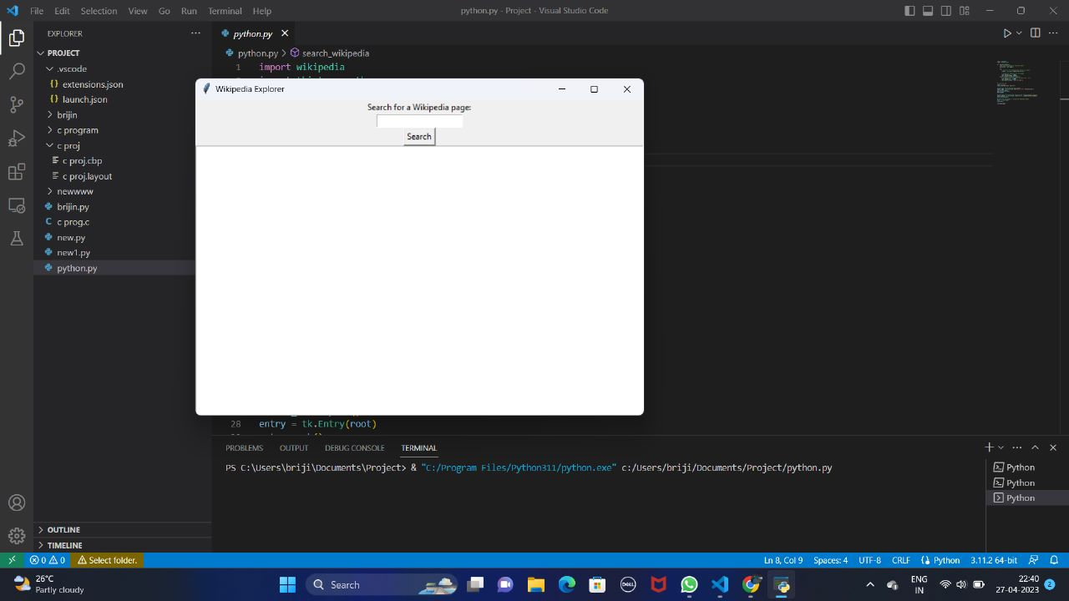

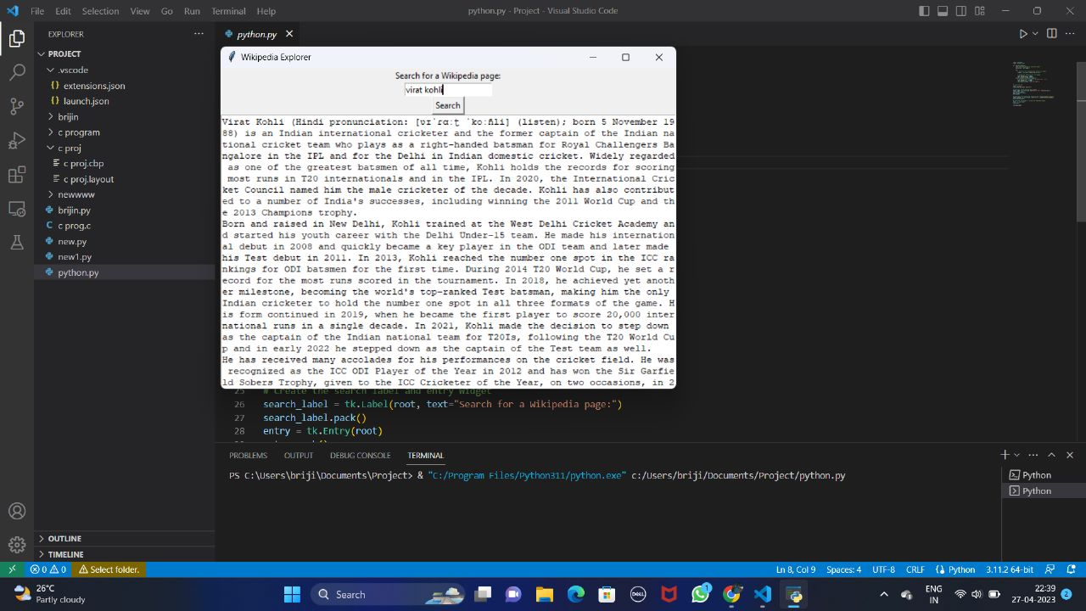

**CONCLUSION**

Python libraries and functions that can be used to access, analyze and manipulate Wikipedia data. These libraries provide easy-to-use interfaces for accessing Wikipedia content, searching for articles, and extracting specific information from Wikipedia pages. By using these tools, developers and data scientists can easily access and analyze the vast amount of knowledge stored in Wikipedia, and use it for a wide range of applications, including data analysis, natural language processing, and machine learning. Overall, the Wikipedia Explorer in Python can be a powerful tool for exploring the vast amount of information available on Wikipedia, and for gaining insights into various topics and areas of interest.